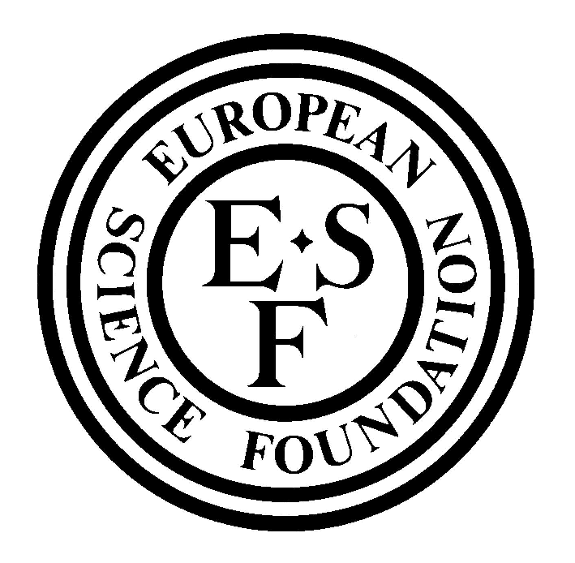 |  | Standing Committee for the Humanities  OMLL: The Origin of Man, Language and Languages  A EUROCORES (European Science Foundation Collaborative Research) Programme
Workshop
“Languages and genes: recent work and emerging results”
Aussois, 22-25 September 2005
 | Family Name
 | First Name
 | Title
 | Sex
 | Nationality
 | Age or age bracket by decade
 | Position
 | OMLL Status and CRP No. (if applicable)
 | Academic Institution / University
 | Full mailing address of Institution
 | Tel
 | Fax
 | E-mail
 | Website
 | Scientific expertise
The information provided on this form will be entered into the ESF database. The ESF website and database have been declared at the Commission Nationale de l’Informatique et des Libertés (CNIL). In accordance with Law No. 78-17 of January 1978 on information processing, electronic files and civil liberties you have a right to access and update the personal information about you and to ask for such information to be deleted etc. For further information please send an email to the person responsible for the protection of data at cnil@esf.org.
Participants acknowledge and agree that photographs taken during the science meeting can be used by the local organiser and ESF for the promotion of their networking activities.

 | (date and signature)

