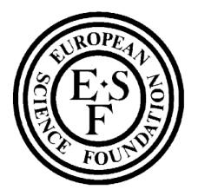
European Science Foundation

EUROCORES (EUROpean Science Foundation

COllaborative RESearch) Programme <<
Workshop
Languages and genes: recent work and emerging results
Aussois: 22-25 September 2005

Participation and Accommodation

Name

Please tick the appropriate boxes below

I will attend the meeting YES NO

I require a single room YES NO
I require a double room YES NO
(additional cost for 2nd person to be paid for by participant)

for the nights of:
Thursday 22nd September 2005 YES NO
Friday 23rd September 2005 YES NO
Saturday 24th September 2005 YES NO
Sunday 25th September 2005 YES NO

Any other night(s):

Arrival time:
Departure time:

Any dietary needs:

Please complete and return this form by e-mail as soon as possible to both of the following addresses:

Claire Rustat-Flinton
European Science Foundation
1 quai Lezay-Marnésia
BP 90015
67080 Strasbourg Cedex
France
Email: crustat@esf.org

Laurent Sagart
CRLAO
Laurent Sagart
54 Bd Raspail
75270 Paris Cedex 06
France
Email: sagart@ehess.fr

